**Families and Communities**

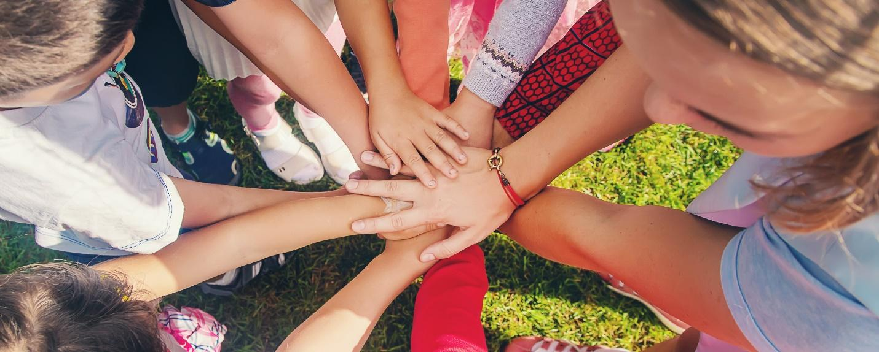

**Celebrating and Supporting School Efforts!**

Recently, the Florida Positive Behavioral Interventions and Supports (FLPBIS) project awarded Blue Angels Elementary the 2023-2024 Bronze PBIS Model School status. This award recognizes our efforts to enhance student quality of life by implementing a Positive Behavioral Interventions and Supports (PBIS) framework. As a PBIS Model School, **we demonstrate a commitment to positive outcomes for all students!**

**What is PBIS?**

PBIS is an evidence-based three-tiered prevention framework to improve and integrate the data, systems, and practices impacting student outcomes. National research shows that full implementation of PBIS leads to reduced exclusionary discipline and improved student and teacher outcomes. With the PBIS framework, we are developing skills, making improved system changes to our school environment, acknowledging appropriate behavior, and using data to identify supports for all our students.

|  |  |
| --- | --- |
| **PBIS Framework** | **PBIS Goals** |
| 1. Build safe and positive school climates. 2. Enhance and support effective school systems. 3. Include input and support from all partners:    1. Faculty and staff    2. Students and families    3. Community members | 1. Create environments that help students achieve success. 2. Develop positive and supportive relationships among partners. 3. Prevent problem behaviors from occurring. 4. Teach appropriate behaviors. 5. Acknowledge appropriate behaviors of all partners. |

**Family and Community Members as Partners**

As a part of these efforts, time and resources are dedicated to student, family, and community relationships. Close participation of family and community members is critical for student success.

**What can you do as a family member to support PBIS?**

1. **Share your knowledge** **about how your child learns best** and ways for supporting your child’s behavior, including background and cultural information, with your child’s teacher and school staff.
2. **Ask your child’s teacher** about options for ensuring that home-school communication is maintained and that positive experiences, as well as any concerns, can be discussed proactively.
3. **Express your interest in your child’s education** to both your child and to his/her teacher. Talk to your child about the importance of education and positive behavior. Ask your child for specific examples that illustrate behavior demonstrating the Tier 1 expectations throughout their day (e.g., “*How did you show Responsible behavior during math today?”*)
4. **Express your interest in the success of the school** by asking your child’s principal and classroom teacher on options to engage with and participate in areas of importance to you and the school.
5. **Share your understanding of your child’s issues** with your child’s teacher. Ask your child’s principal and teacher how you can help in problem-solving within the school and community.

**What can you do as a community member to support PBIS?**

1. **Share knowledge about community resources** with school staff and family members.
2. **Provide and support** the school’s access to resources.
3. **Look for opportunities to reinforce** behavioral expectations and provide acknowledgements to students within and across community settings.

**Recognizing Hard Work**

As a result of our work, Blue Angels Elementary is being recognized by the FLPBIS Project as a 2023-2024 PBIS Model School. To earn this achievement, schools must meet specific criteria that can be found on the FLPBIS Project website. This award demonstrates our commitment to positive outcomes for all students and helps us celebrate our efforts as we continue to strive for the highest quality implementation of PBIS. To learn more about FLPBIS Project Model Schools visit [www.flpbis.org](http://www.flpbis.org).